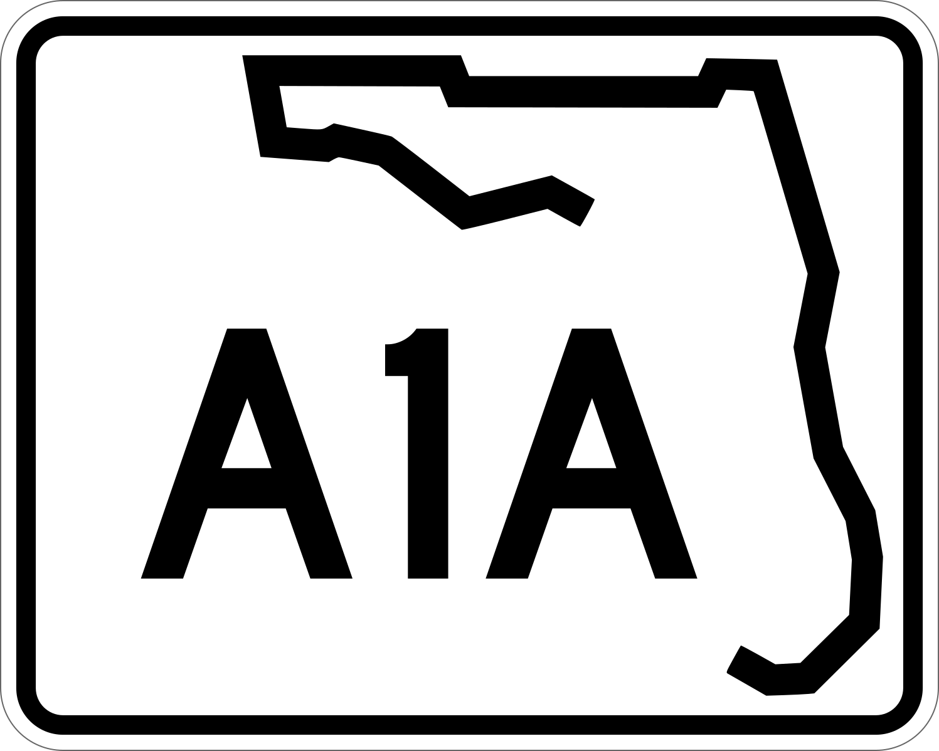

Citizens Traffic Task Force Newsletter

Summer 2021
PONTE VEDRA BEACH
Citizens Traffic Task Force

The Citizens Traffic Task Force Board includes representatives from:

The Ponte Vedra
Municipal Service District

The Ponte Vedra
Community Association

Sawgrass
Master Association

Ponte Vedra Coalition

The Palm Valley
Community Association

The Plantation at
Ponte Vedra Beach

Sawgrass Players Club
Master Association

Marsh Landing
Master Association

North Ponte Vedra Beach Coalition

Welcome to the Ponte Vedra Beach Citizen’s Traffic Task Force Summer 2021 Newsletter. As has so often been said in this newsletter, funding is a critical, if not the most critical, component of the path to roadway improvement in any community. Because we live and work in such a desirable area, and not just Ponte Vedra Beach, think our county, region or state, we see the results of population growth all around us. That means that the need for infrastructure investment is widespread in Florida. Here in Northeast St. Johns County we are fortunate to be represented by a legislative delegation, State Senator Travis Hutson, and Representatives Cyndi Stevenson and Paul Renner, who, during the past three years, have made it a priority to support allocations in the state budget for roadway improvements in our community. In 2019 that number was $500K, in 2020 we were granted another $1.0M, and in 2021 another $1.65M. These targeted funds have been provided to St. Johns County through the Florida Department of Transportation (FDOT) specifically for intersection improvements in Ponte Vedra Beach. The $500K from 2019 is funding the initial improvements at the Solana Road-A1A intersection, and the $1.0M from 2020 and the $1.65M from 2021 will be used for the Mickler Road-A1A interchange upgrade. As these improvements begin to take shape, we should all remember to give a big “thank you” to our legislators.

Improvements to the Solana Road – SR A1A Intersection Beginning

Construction crews have already begun working on improvements at the intersection of Solana Road and State Road A1A. During the last week of July, crews began setting up erosion control measures. Construction will extend the “stacking lanes” southbound on A1A to Solana Road (for both left and right turns) and eastbound on Solana Road to A1A. While these will be relatively minor improvements, they should provide some immediate relief, especially during the peak commuting hours. It is believed that the work on turn lanes will have minimal impact on traffic flow during construction. There will be no lane closures before 9:00AM or after 3:00PM. According to the county’s Public Works Department, work is scheduled to be completed in September.

Plans for Improvements to the SR A1A and Mickler Road Intersection

Progress continues towards improvements to the intersection at A1A and Mickler Road. This project will include the construction of new left turn lanes from Mickler Road onto State Road A1A. A design firm has now been selected. According to the county’s Public Works Department, design will begin in August 2021 with construction scheduled for 2022. Once the design phase has been completed, public meetings will be announced to share design plans and collect input from the local community.
PONTE VEDRA BEACH
Citizens Traffic Task Force

PONTE VEDRA BEACH
Citizens Traffic Task Force

The Citizens Traffic Task Force Board includes representatives from:

The Ponte Vedra
Municipal Service District

The Ponte Vedra
Community Association

Sawgrass
Master Association

Ponte Vedra Coalition

The Palm Valley
Community Association

The Plantation at
Ponte Vedra Beach

Sawgrass Players Club
Master Association

Marsh Landing
Master Association

North Ponte Vedra Beach Coalition
FEMA Protective Beach Berm Project Set to Begin Soon

This Federal Emergency Management Agency project will place protective sand on berms that were severely eroded during Hurricanes Matthew and Irma. During the term of this project, approximately 19,000 truckloads of sand, or 200 truckloads a day, will travel from the Keystone Heights mine to Cornerstone Park in Ponte Vedra Beach where trucks will be staged prior to dropping their loads. The trucks will come in early each day beginning about 6:00 AM. From Cornerstone Park the trucks will be released one at a time to the access points including Mickler’s Landing Beachfront Park and the empty lots at 725 and 965 Ponte Vedra Boulevard. At each access point the trucks will either bring sand directly onto the beach or use the access point as a staging/dumping area from which a backhoe will move the sand over the dune. Expect Mickler’s Landing Beachfront Park to be closed Monday through Friday from November 1, 2021 to late spring 2022. Beach access will be open on the weekends during this time.

There will be a police presence at intersections, access points and on the beach. Their role is to ensure public safety and maintain adequate traffic flow. The planned route from Cornerstone Park to the drop points is via A1A to Mickler Road and from there onto Ponte Vedra Boulevard. There are no plans to utilize Solano or Corona at this time.

Portions of the dune restoration project will likely occur simultaneously for both the north and the south ends of Ponte Vedra Beach. During the project a total of 9 miles of coastline will be restored. 85% of the property owners along that route have already agreed to provide access and participate in dune restoration. Applications from homeowners who have not yet opted in will be accepted up to 2 weeks before work begins in a homeowner’s area.

Sand placement for the north end of the project will likely begin November 1. Sand placement for South Ponte Vedra Beach is currently scheduled to begin right after Labor Day. The contractor has been asked to be substantially complete by February 28, 2022. The hard end date set by FEMA has been recently moved to June 30, 2022. It is desired that the project be completed before the beginning of the turtle nesting season.

Roscoe Boulevard and Palm Valley Bridge Intersection Improvements

This project will upgrade the Roscoe Boulevard and Palm Valley Bridge intersection to include a traffic signal, an additional pedestrian crossing, and an extended sidewalk along the northern portion of Palm Valley Road to the Sawmill Lakes Community. The 60% portion of the design plan for the new signal at Palm Valley Road and Roscoe Boulevard is due to be submitted to the county for approval on August 17, 2021.

PONTE VEDRA BEACH
Citizens Traffic Task Force

The Citizens Traffic Task Force Board includes representatives from:

The Ponte Vedra
Municipal Service District

The Ponte Vedra
Community Association

Sawgrass
Master Association

Ponte Vedra Coalition

The Palm Valley
Community Association

The Plantation at
Ponte Vedra Beach

Sawgrass Players Club
Master Association

Marsh Landing
Master Association

North Ponte Vedra Beach Coalition
JEA Waterline Project Along Ponte Vedra Boulevard

The installation of a larger water main along Ponte Vedra Boulevard between Corona Road and Pablo Road is now about 50% complete. Construction began in February, and approximately 1,500 feet of the new water main has been installed. The new water main will enhance water supply and water pressure in the community. The project is scheduled for completion in September or October 2021.

County Road 210 and Mickler Road Roundabout Intersection Improvement
Improvements currently under consideration for the roundabout at the County Road 210, Palm Valley Road, and Mickler Road intersection are intended to increase intersection capacity and provide a better flow of traffic. The design phase of the project will begin in 2021. The recommendation for the vendor who will perform the design services for the Mickler roundabout/intersection is scheduled to go before the Board of County Commissioners on September 7.
State Road A1A and Marsh Landing Parkway to Marlin Ave. Intersection Improvements

Planned improvements to traffic flow for the section of SR A1A from Marsh Landing Parkway to south of Marlin Avenue will include the construction of southbound turn lanes along State Road A1A at the Ponte Vedra Lakes Boulevard, Ponte Vedra Parks Drive, and Marlin Avenue intersections. The Florida Department of Transportation has added this project to its five-year program with $700,000 allocated in FY22/23 and $2,500,000 in FY23/24.

_____________________

The Citizen’s Traffic Task Force Newsletter is produced in collaboration with St. Johns County’s Public Works Department. St. Johns County is dedicated to providing the highest level of service to the residents in Ponte Vedra Beach. For more information regarding upcoming projects, please visit www.sjcfl.us.

